Ulvi Bajarani
SID 20539914
CSCI 6345 – Advanced Computer Networks
Summer II
Assignment 6
Ethical Hacking in Kali Linux.
1) The first tool that I used is theHarvester, which gets not only the domain information, but also the emails of domain. Here, the start of help page after execution of theHarvester -h to see the help page:

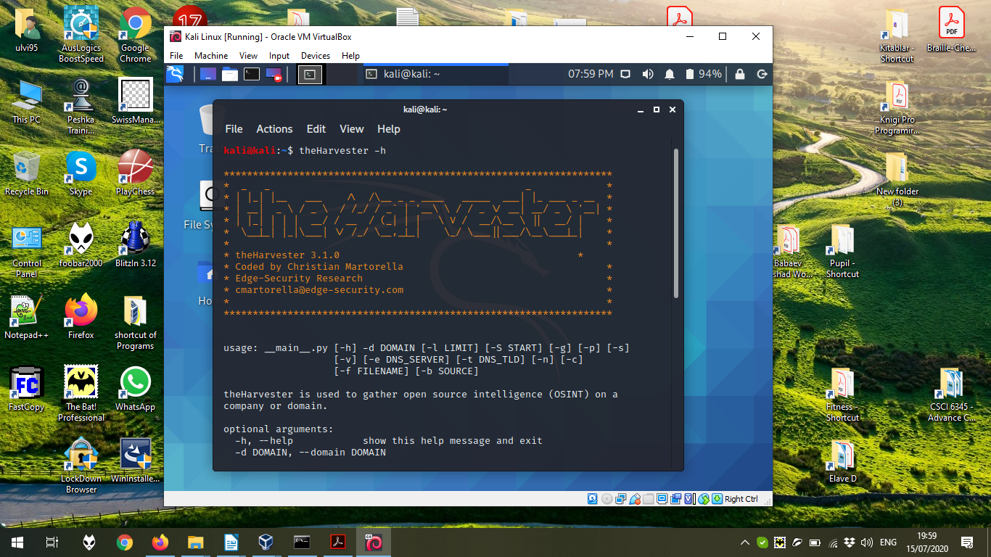

Now, let’s try to execute theHarvester -d kali.org -b google command, where, -d kali.org defines the domain name, -b google defines the search engine:
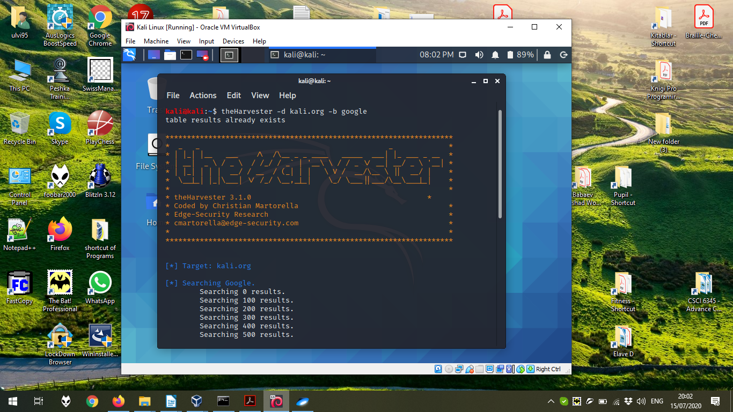

In the bottom, we can see the results:
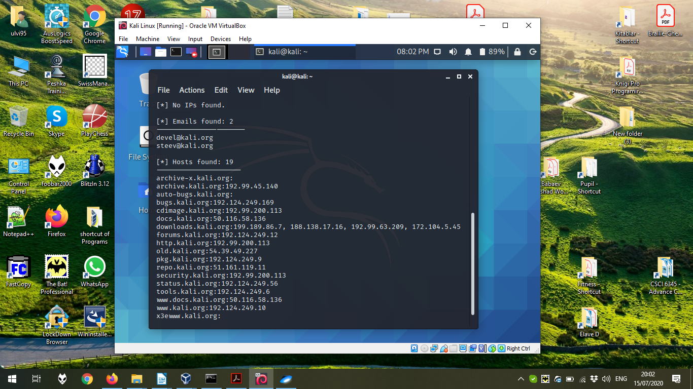

2) Now, let’s try to use more complex program nmap, which can retrieve OS, define the ports, find the hosts, configure the search in an UDP port, IPv6 port, etc. Here, the start of help page after execution of nmap -h to see the help page:
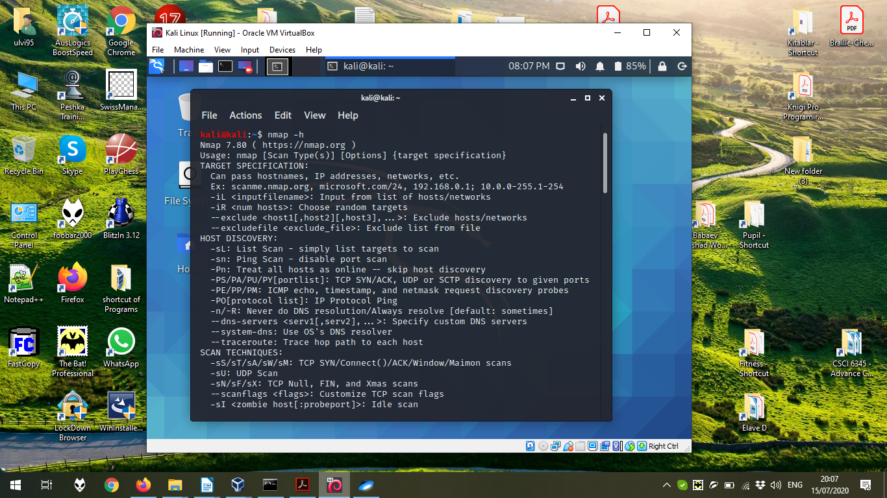

Now, let’s try to execute nmap -v -A scanme.nmap.org, where -v increase the verbosit, -A is the command to enable OS detection, the version detection, script scanning, and traceroute:
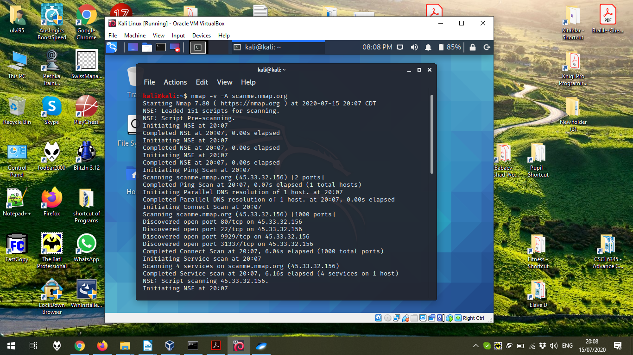

The next page of the execution:
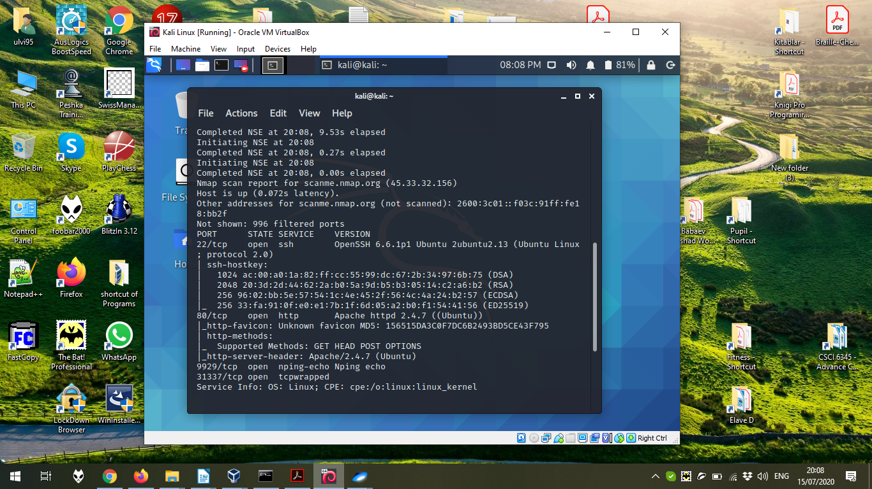

The last page of the execution:
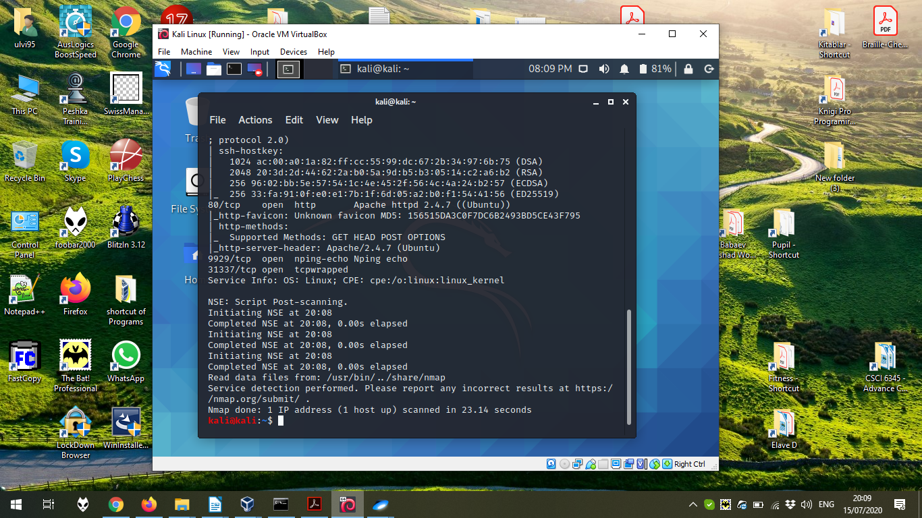

3) It is also possible to use the functions to mask own device. One of them is macchanger, which allows to interfere with the MAC address of the device. Here, we can see the execution of macchanger -h:
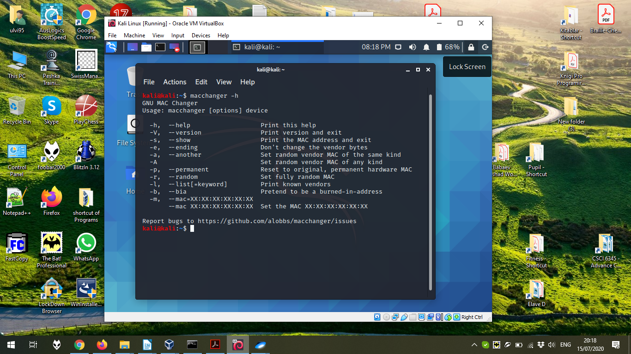

Now, let’s try to change the MAC address of the Ethernet Adapter (eth0) by sudo macchanger -r eth0, where -r stands for the random address. It should be added that by macchanger -l, we can retrieve the list of known devices and their MACs. Here, we just use the random address:


